Practical-8

Aim: Install the Apache Kafka (Single Node) on Windows and perform practical on Kafka.

**Perform following:**

# Create a topic “Mobile” with 2 Partitions and 3 Replication Factors.

1. Produce the messages: “Samsung”, “Nokia”, “Vivo”, “Sony”, “Xiaomi”.

# Consume the messages.

## Step 1: Starting Zookeeper

Open the command prompt

Goto C:\kafkaV2-13\bin\windows and run following command:

.\zookeeper-server-start.bat ..\..\config\zookeeper.properties

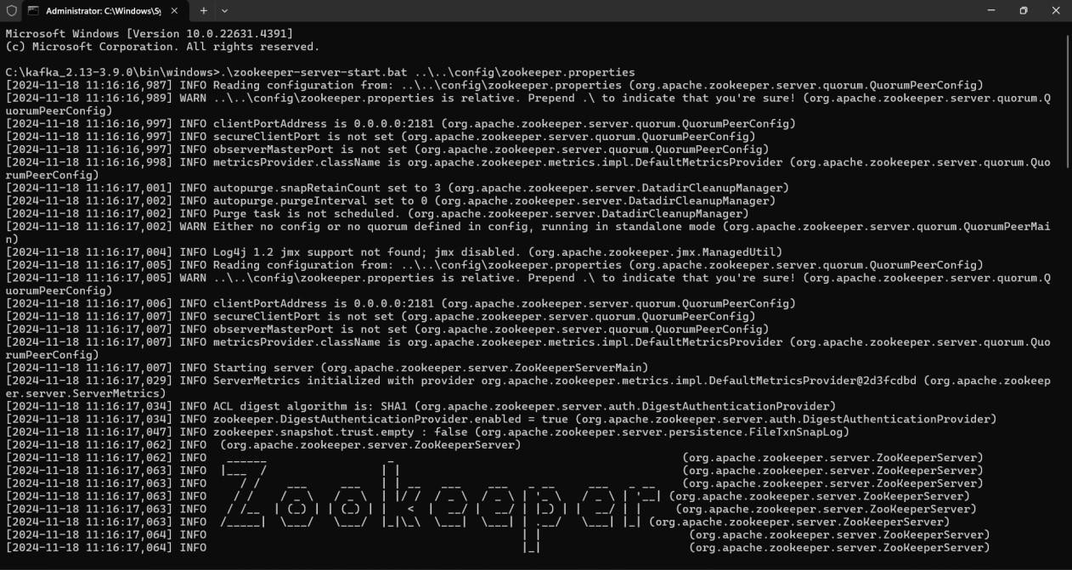

## Step 2: Starting Kafka

Open another command prompt window and type the below command. Goto C:\kafkaV2-13\bin\windows and run following command:

.\kafka-server-start.bat ..\..\config\server.properties

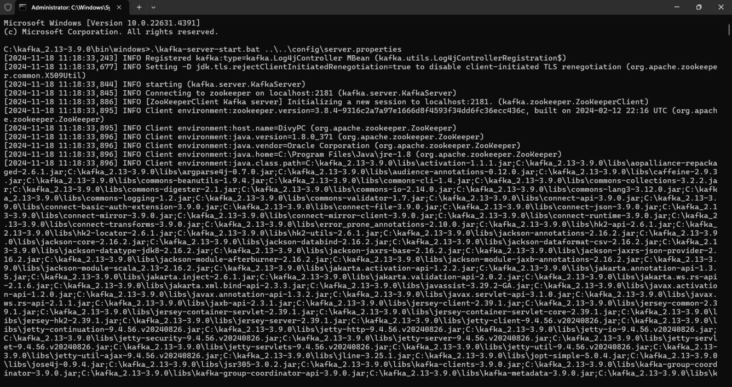

## Step 3: Perform following in Kafka:

Testing Kafka by Creating a Topic: As you have successfully started Kafka and Zookeeper, you can test them by creating new Topics and then Publishing and Consuming messages using the topic name. Topics are the virtual containers that store and organize a stream of messages under several categories called Partitions. Each Kafka topic is always identified by an arbitrary and unique name across the entire Kafka cluster.

In the below steps, you will learn how to create topics:

For creating a topic, open a new command prompt and write the below command: goto C:\kafkaV2-13\bin\windows and run following command:

kafka-topics.bat --create --bootstrap-server localhost:9092 --replication-factor 3 --partitions 2 -- topic mobile

(Output: Created topic mobile.)



## Step 4: Open another CMD terminal

Start sending messages to the topic. Run this command to launch the producer: Run following command:

C:\kafkaV2-13\bin\windows>kafka-console-producer.bat --topic mobile --bootstrap-server localhost:9092

Type in your messages (enter atleast five messages), and hit Enter. (Note: Don't close the terminal (CMD prompt)

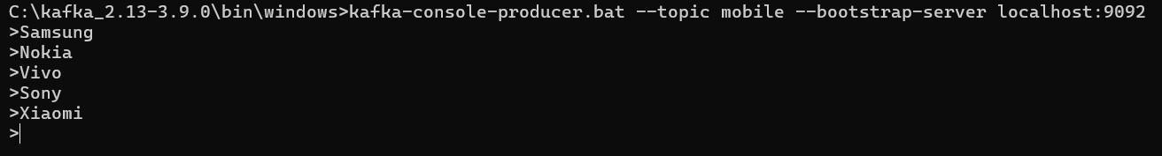

## Step 5: Open another CMD terminal

consume and see the messages which you/producer sent:

Run the following command:

C:\kafkaV2-13\bin\windows>kafka-console-consumer.bat --topic mobile --from-beginning -- bootstrap-server localhost:9092

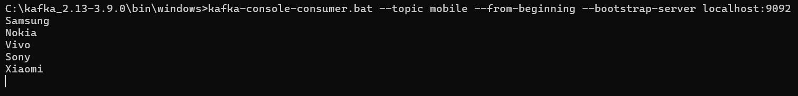

## Producer: Consumer:

**Step 6: List the topics**

Command:

C:\kafkaV2-13\bin\windows>kafka-topics.bat --list --bootstrap-server localhost:9092

